## **7.3 Description prototype SBP**

### 7.3.1 Introduction

For our prototype we created a real-time platform. On the side of the customer who wants to rent a product: after registration the user can filters products and rent the one he wants. After that he can rent a product and have a conversation with the renter to meet up in person.

On the side of the customer who has products to rent: after the registration the user can add a product. Then he can manage the different rentings of the product (when somebody rents it) and chat with the potential renter to meet up in person.

### 7.3.2 Technical

To accomplish a real-time platform we used JavaScript on the frontend as well on the backend. These are the main technologies we used for both sides:

Frontend

* Bootstrap: basis to build a responsive website
* AngularJS: MVC implementation
* UI Bootstap: Bootstrap components written in Angular
* ngAnimate, ngRoute, ngMessage: extensions of Angular for animations, routing and error messages
* Google Maps: auto completion of address (place where you can get the product if you rent it)
* Jasmine: tests on the frontend

Backend

* Node.js: event-driven, non-blocking I/O model
* Express: MVC architecture on the server side
* Jade: template engine
* MongoDB: NoSQL database
* Passport: authentication (+ Google)
* Mongoose: object modeling for database
* Socket-IO: real-time communication between our users (websockets)
* Mocha: tests on the backend
* Cloudinary: image storage

To deploy our website we used a free plan of Heroku. You can find our prototype on <https://swoppr.herokuapp.com/>. In the future we’re going to use a paying plan that is more reliable (e.g. now our server needs to sleep 6 hours a day) and faster. We also going to choose for a custom domain (preferring swoppr.be).

### 7.3.3 Intro page

Our first page is accessible for everyone that access our page (also not authorized users). In this page we persuade our potential customers to use our service. Our page is divided in 4 sections:

* Short description of platform, with a call to action to register and active photo
* Our platform described in two paragraphs and our four USP’s
* A slideshow with two familiar situations
  + First one: Do you only use your lawn mower in the weekends? Earn money with it in the weekdays.
  + Second one: Only use a wheelbarrow when moving in? Rent now a wheelbarrow for this period.
* The different members of our team with each their function, if you hover on them, you can visit them on their social media pages

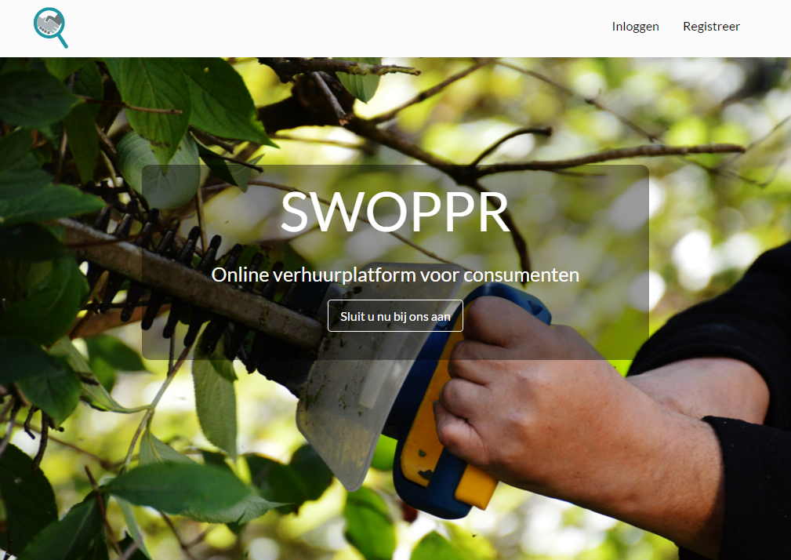

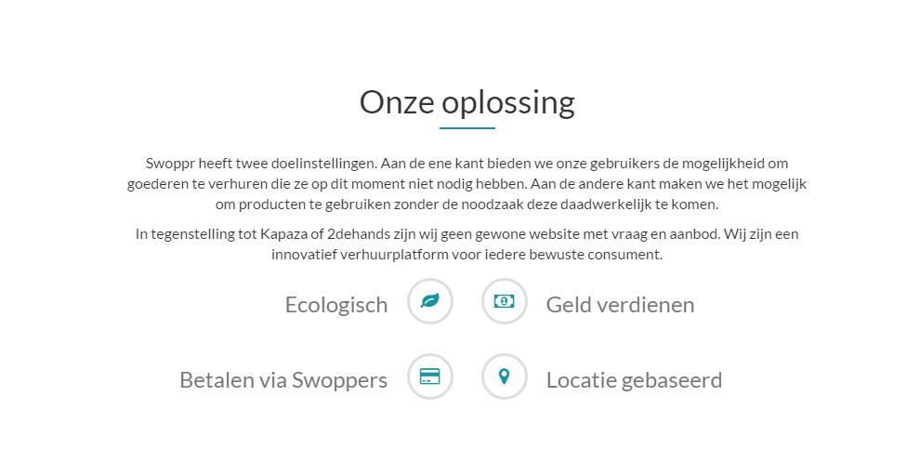

 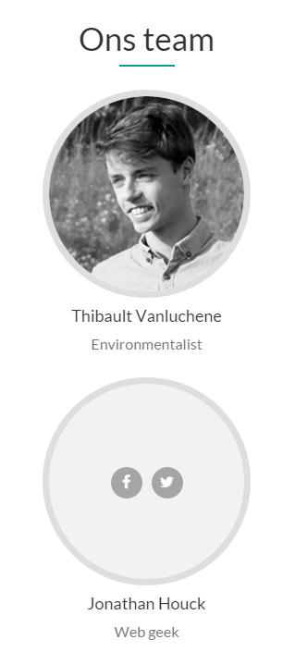

### 7.3.4 Authentication

In the register page you can fill in the required fields (name, email and password (2x)) and authenticate. Once you’re registered, you can authenticate at the login page. Once you’re authenticated you can add your Google account in the profile page. After that you can authenticate with one click on the login page, without this feature the user can authorize faster.

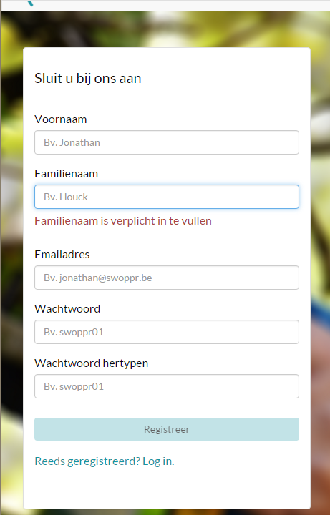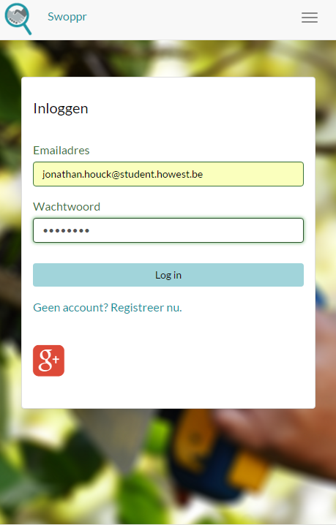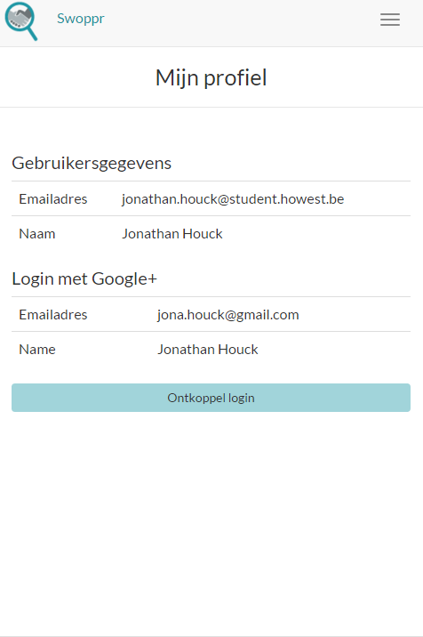

### 7.3.5 Add a product + detail

Authenticated users can place a product on our platform that can be rented by other users. When you place a product you have to fill in an intuitive name, a short description and the amount of money you want for the product. You also have to fill in your address, after you selected the address in the autocomplete (from Google Maps), the location is pointed on the map and the address is valid. It’s also possible to upload a clear image of the product.

Once we’ve integrated online payment in our platform, we’re going to use our own currency, Swoppers.

When you have added a product you go the detail of that product where you can see all the required information (name, description, amount and location) plus the image (if you uploaded one).

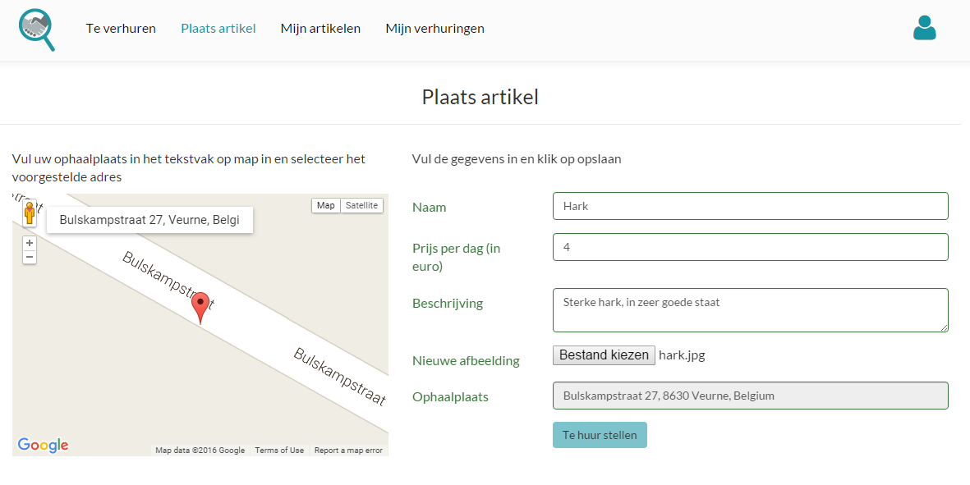

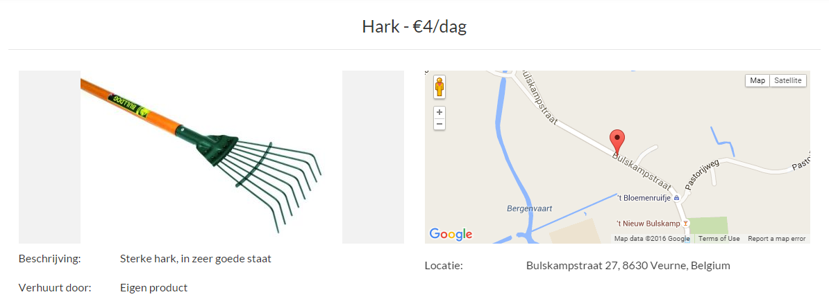

### 7.3.6 Management of products

Every user can manage their products with the possibility to navigate to the detail of those products. Here you can edit or delete the product.

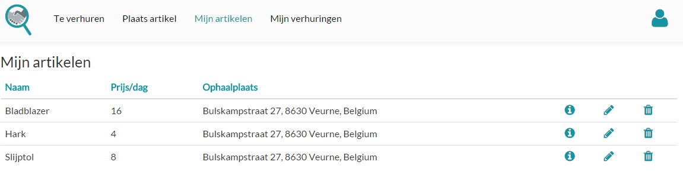

### 7.3.7 Overview of products + search

In the overview of products you see the most recent product that users added to our platform. In our next version the first products you see are those who are placed in the spotlight (you can place products in the spotlight by paying 50 Swoppers).

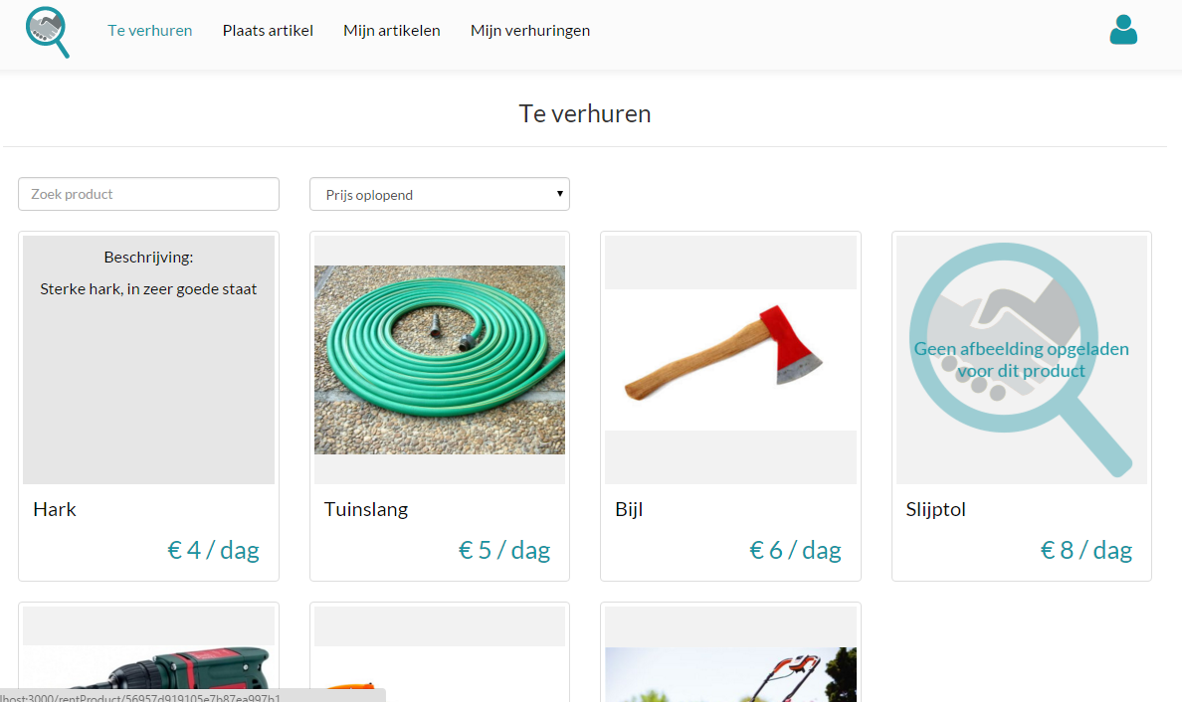

In this page a search is also integrated, you can also sort on the name of a product and price. Later we’re planning a more extended search, with a filter that includes all the required fields (name, description and price) plus the name of the renter.

### 7.3.8 Rent a product + detail

In the overview of product you can click on a product or in the detail page you can click on the call to action “Rent product”.

Once clicked, you come the page where you can rent the product. Here you can select the “from” and “to” date with a date picker, this is the period when you want to rent the product. You can see in real-time the amount of days and the total price. The date pickers aren’t giving any error message because we’ve put logic in them so you can’t select the wrong date. E.g. when you want to select the “to” date, the minimum date is set so you can’t select a date before the “from” date.

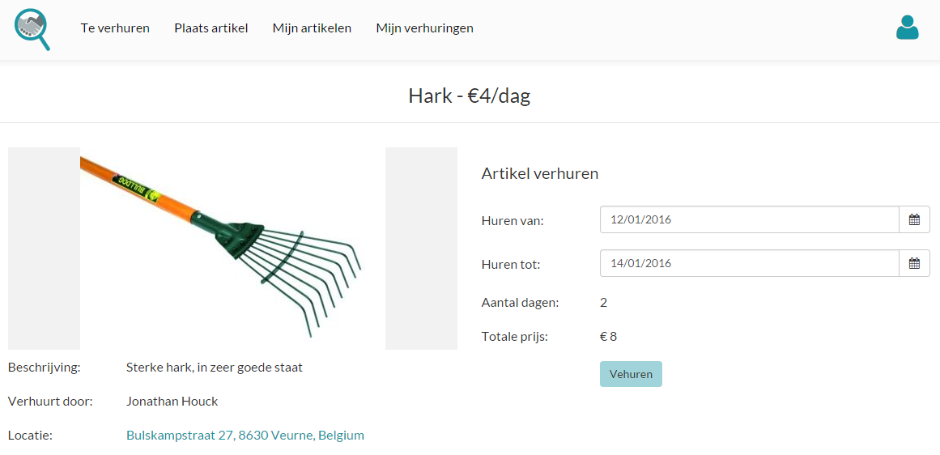

Once clicked on the button to rent the product, you’re going to the detail of that renting where you see all the information about the renting. You have also the possibility to chat with the person who rents it. Here you can also navigate to the detail of the involved product.

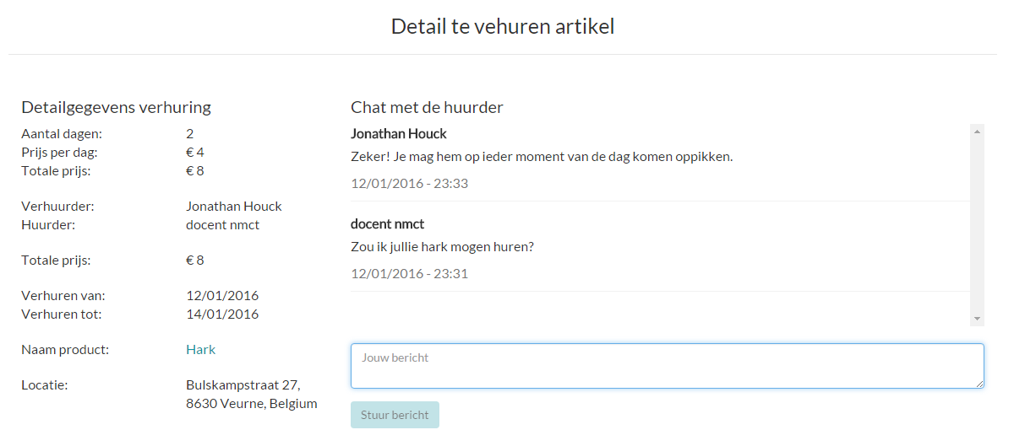

### 7.3.9 Management of rentings

Every user can manage their rentings with the possibility to navigate to the detail of those rentings. The rentings are divided in two categories:

* The rentings where you rent the product to other people
* The rentings where you rent the product from other people

Here you have the possibility to delete the rentings of each category. In rentings where you rent the product from other people you have also the possibility to edit the renting.

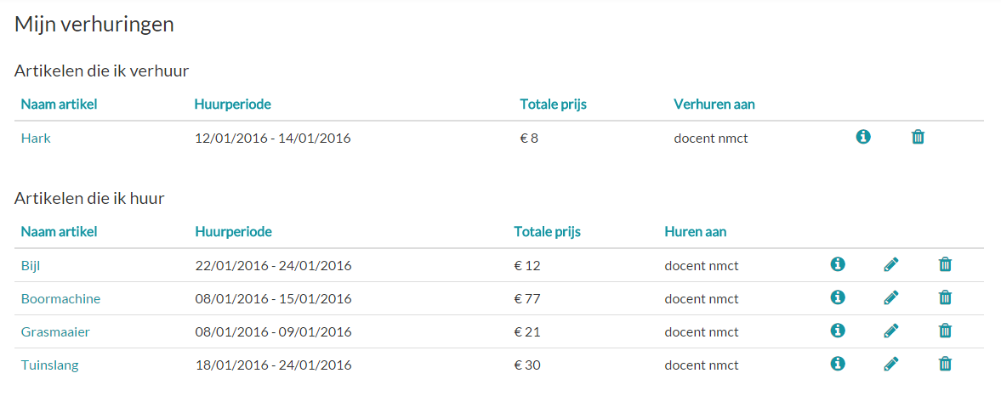

### 7.3.10 Future plans

This is a summary of the features we’re going to integrate.

* Place products in the spotlight
* More extended search
* States when the renting is approved or not
* Support of multiple login methods with social media (Facebook, Twitter …)
* Customer support: chat functionality with the people of the customer support. Here it would be a good idea to detect the page where’s the user at, to give more personalized support
* Statistics for the administrator
* Features for the administrator
  + Management of users
  + Possibility to delete inappropriate product
* Integration with payments